1.0 Brake Telltale 2015 S550 SVT Specific – CGEA1.3

Functional Description

The purpose of the Brake Indication Function is to inform the driver of the following: The Park Brake is engaged, the brake fluid level is low, there is a failure in the base brake system, or there is an issue with the electric park brake.

The Brake Indication Function correlates the BrkLamp_B_Rq signal, the Operational_Mode, the BrkWarnInd_B_Rq signal, and the PrkBrkRedLamp_D_Rq signal, and BrkPadMsgTxt_D_Rq signal to illuminate, flash or extinguish the Brake Telltale. The Brake Indication Function also correlates the PrkBrkYwLamp_D_Rq signal and the Operational_Mode to illuminate, flash or extinguish the Electric Park Brake Telltale.

For certain 2015 S550 SVT applications ceramic brake pads are employed. Ceramic brake pads do not have the wear strips standard brake pads have to provide an audible warning that the brake pads are worn out. Per regulation an audible or visual warning is required for worn out brake pads. For SVT applications equipped with ceramic brake pads the brake telltale is therefore illuminated when the ceramic brake pads are worn out. VDM sends BrkPadMsgTxt_D_Rq signal to IPC to light the brake telltale for worn out brake pads. At text message is provided to provide clarifying information as to why the brake telltale is illuminated. See Warning – ceramic Brake Pad Wear – 2015 S550 SVT Specific STSS for the text warning function.

The Brake Indication Function shall provide a red iconic representation that will illuminate, flash or extinguish to inform the driver of brake issues. If the vehicle is configured with an Electric Park Brake (EPB) system, Brake Indication Function shall also provide a yellow iconic representation that will illuminate, flash or extinguish to inform the driver of electric park brake issues.

Due to recent developments, for EPB faults, ECE markets must use symbol B.01 shown in yellow while non-ECE markets must use symbol B.254 shown in yellow without the word BRAKE. ECE markets must use symbol B.01 shown in yellow per regulations ECE121 and ECE R13H. .

It was first proposed that symbol B.01 shown in yellow be used worldwide, however, it was identified that China, Canada, and certain other markets per regulation do not allow symbol B.01 to be shown in yellow (red only is allowed) and the red symbol is reserved for brake faults/park brake applied. It was therefore decided that for all non-ECE markets the current B.254 symbol shown in yellow without the word BRAKE (CD4.1 c/o) shall be used for EBP faults.

Interfaces

Interface Context Diagram (I/O Block Diagram)
Figure 1 - Brake Indication Function

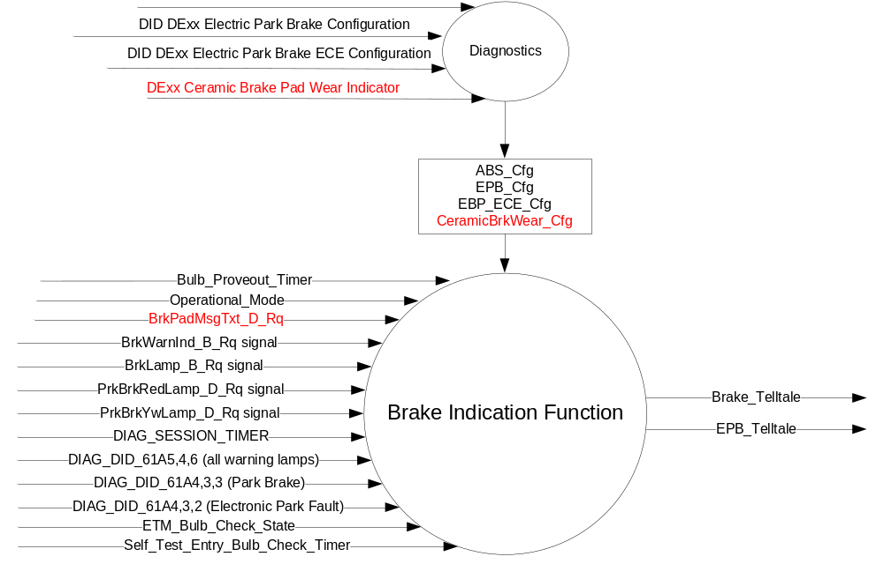

Inputs
      - INTERNAL:
            - DIAG_SESSION_TIMER
            - Operational_Mode
            - Bulb_Proveout_Timer
            - DIAG_DID_61A5,4,6 (all warning lamps)
            - DIAG_DID_61A4,3,3 (Park Brake)
            - DIAG_DID_61A4,3,2 (Electronic Park Fault)
            - ETM_Bulb_Check_State
            - Self_Test_Entry_Bulb_Check_Timer

      - MUX message on the CAN Bus

BrkPadMsgTxt_D_Rq Signal
Signal Name | Size (bits) | Detail | Units | Res. | Offset | State  Encoded | Min | Max
BrkPadMsgTxt_D_Rq | 1 |  | SED | 1 | 0 |  | 0 (0x0) | 3 (0x3)
 |  | Null |  |  |  | 0x0
 |  | Replace Pads |  |  |  | 0x1
 |  | PadsOk |  |  |  | 0x2
 |  | Faulty |  |  |  | 0x3

BrkLamp_B_Rq Signal

Signal Name | Size  (bits) | Detail | Units | Res. | Offset | State Encoded | Min. | Max.
BrkLamp_B_Rq | 1 |  | SED | 1 | 0 |  | 0 (0x0) | 1 (0x1)
BrkLamp_B_Rq |  | No |  |  |  | 0x0
BrkLamp_B_Rq |  | Yes |  |  |  | 0x1

BrkWarnInd_B_Rq Signal

Signal Name | Size  (bits) | Detail | Units | Res. | Offset | State  Encoded | Min. | Max.
BrkWarnInd_B_Rq | 1 |  | SED | 1 | 0 |  | 0(0x0) | 1(0x1)
BrkWarnInd_B_Rq |  | Off |  |  |  | 0x0
BrkWarnInd_B_Rq |  | On |  |  |  | 0x1

PrkBrkYwLamp_D_Rq Signal

Signal Name | Size  (bits) | Detail | Units | Res. | Offset | State  Encoded | Min. | Max.
PrkBrkYwLamp_D_Rq | 2 |  | Unitless | 1 | 0 |  | 0 (0x0) | 3 (0x3)
 |  | Off |  |  |  | 0x0
 |  | On |  |  |  | 0x1
 |  | Slow_Flash |  |  |  | 0x2
 |  | Fast_Flash |  |  |  | 0x3

PrkBrkRedLamp_D_Rq Signal

Signal Name | Size  (bits) | Detail | Units | Res. | Offset | State  Encoded | Min. | Max.
PrkBrkRedLamp_D_Rq | 2 |  | Unitless | 1 | 0 |  | 0 (0x0) | 3 (0x3)
 |  | Off |  |  |  | 0x0
 |  | On |  |  |  | 0x1
 |  | Slow_Flash |  |  |  | 0x2
 |  | Fast_Flash |  |  |  | 0x3

Outputs
Brake_Telltale, which is used to control the state of the red LED
EPB_Telltale, which is used to control the state of the yellow LED

Function/Performance

Operational Modes

Mode | Differentiating Vehicle Conditions
Sleep Mode | Brake and EPB Telltale OFF
Limited Mode | Brake and EPB Telltale ON / OFF / FLASH
Normal Mode | Brake and EPB Telltale ON / OFF / FLASH
Crank Mode | Brake and EPB Telltale ON / OFF / FLASH

Voltage Levels

Refer to the Cluster Features table located in the Operational Modes and Voltage Range Strategies section in this SPSS

Human-Machine Interface

Visual

Indicator Graphics / Display Format

Symbol for Brake_Telltale flag (Brake Telltale):



For actual symbol definition refer to database #'s B.01 and B.02 of the 03-0685 ARL requirement.

Letters "BRAKE" within the above symbol must be 3.2mm tall minimum over design tolerance. Reference REG07 SDS requirement GR-0482.

Symbol for EPB_Telltale flag (Electric Park Brake Telltale) for Non ECE applications:
(EBP_ECE_Cfg = Disabled) :



For actual symbol definition refer to database # B.254 of the 03-0685 ARL requirement.
Note #B.254 symbol used without word BRAKE.

Symbol for EPB_Telltale flag (Electric Park Brake Telltale) for ECE applications.
(EBP_ECE_Cfg = Enabled) :



For actual symbol definition refer to database # B.01 of the 03-0685 ARL requirement.
Note: B.01 symbol is used but shown in yellow. This symbol shown in yellow CANNOT be used for Chinese, Canadian and certain other non-ECE markets per regulation.

Indicator Color Coordinates

Brake Telltale: Red - Reference SDS IH-0001/IS-0379
Electric Park Bake Telltale: Yellow - Reference SDS IH-0001/IS-0379

Indicator Characteristics

LED – Brake Telltale.
LED – Electric Park Brake Telltale.

Audio

None associated with FMVSS brake telltale, however, see Message Center Warning Chime and Park Brake Warning Chime STSS for related chimes that may occur while the Brake FMVSS telltale is lit.

Switch Control Logic

Not applicable.

System Accuracy

The Brake_Telltale shall change the state of the Telltale within 100msec of a state change as indicated in the state matrix reference 1.3.5.1 Subsystem Algorithm Flowchart/ State Diagram.

The EPB_Telltale shall change the state of the Telltale within 100msec of a state change as indicated in the state matrix reference 1.3.5.1 Subsystem Algorithm Flowchart/ State Diagram.

Operation: Performance and Functional

Subsystem Algorithm Flowchart / State Diagram
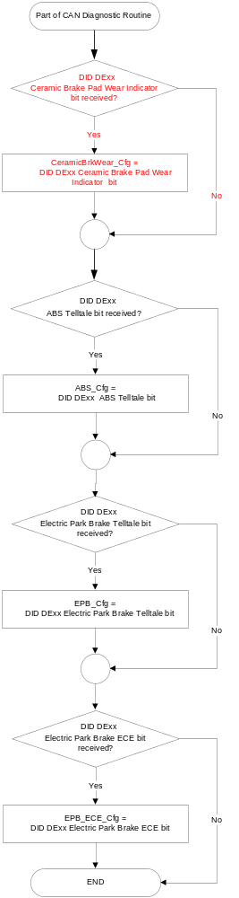
- State Matrix for Brake Telltale

Operational_ Mode | ABS_  Cfg | EPB_  Cfg | CeramicBrk  Wear_Cfg | ETM Bulb_ Check_  State | DIAG_SESSION  _TIMER | Self_Test_ Entry_Bulb_ Check_  Timer | DIAG_DID_  61A4,3,3  (Park Brake) | DIAG_DID_  61A5,4,6  (all warning lamps) | Bulb_  Proveout_  Timer | BrkLamp_B_Rq Signal | BrkWarnInd_B_Rq Signal | PrkBrkRed  Lamp_D_Rq Signal | BrkPadMsgTxt_D_Rq | PrkBrkRed  Missing  Timer | Brake_  Telltale
Limited | X | Enabled | X | X | Not Active | X | X | X | X | X | X | On (0x1) | X | X | ON
Limited | X | Enabled | X | X | Not Active | X | X | X | X | X | X | Slow_Flash (0x2) | X | X | Flash @ .5Hz  50% Duty Cycle
Limited | X | Enabled | X | X | Not Active | X | X | X | X | X | X | Fast_Flash (0x3) | X | X | Flash @ 2Hz  50% Duty Cycle
Limited | X | Enabled | X | X | Not Active | X | X | X | X | X | X | Declared missing as per SPSS | X | Running and < 10 s | No State  Change
Limited | X | Enabled | X | X | Not Active | X | X | X | X | X | X | Never Received | X | X | OFF
Normal or Crank | X | X | X | X | Not Active | X | X | X | Active | X | X | X | X | X | ON
Normal or Crank | X | X | X | X | Not Active | X | X | X | X | X | On (0x1) | X | X | X | ON
Normal or Crank | Enabled | X | X | X | Not Active | X | X | X | X | Yes (0x1) | X | X |  | X | ON
Normal or Crank | Enabled | X | X | X | Not Active | X | X | X | X | Declared missing as per SPSS | X | X | X | X | ON
Normal or Crank | X | X | X | X | Not Active | X | X | X | X | X | Declared missing as per SPSS | X | X | X | ON
Normal or Crank | Enabled | X | X | X | Not Active | X | X | X | X | Never Received | X | X | X | X | ON
Normal or Crank | X | X | X | X | Not Active | X | X | X | X | X | Never Received | X | X | X | ON
Normal or Crank | X | X | X | ON (0x1) | Not Active | X | X | X | X | X | X | X | X | X | ON
Normal or Crank | X | Enabled | X | X | Not Active | X | X | X | X | X | X | On (0x1) | X | X | ON
Normal or Crank | Enabled | Enabled | X | X | Not Active | X | X | X | Inactive | No (0x0) | Off (0x0) | Slow_Flash (0x2) | X | X | Flash @ .5Hz  50% Duty Cycle
Normal or Crank | Enabled | Enabled | X | X | Not Active | X | X | X | Inactive | No (0x0) | Off (0x0) | Fast_Flash (0x3) | X | X | Flash @ 2Hz  50% Duty Cycle
Normal or Crank | Disabled | Enabled | X | X | Not Active | X | X | X | Inactive | X | Off (0x0) | Slow_Flash (0x2) | X | X | Flash @ .5Hz  50% Duty Cycle
Normal or Crank | Disabled | Enabled | X | X | Not Active | X | X | X | Inactive | X | Off (0x0) | Fast_Flash (0x3) | X | X | Flash @ 2Hz  50% Duty Cycle
Normal or Crank | X | Enabled | X | X | Not Active | X | X | X | X | X | X | Declared missing as per SPSS | X | X | ON
Normal or Crank | X | Enabled | X | X | Not Active | X | X | X | X | X | X | Never Received | X | X | ON
Normal or Crank | X | X | Enabled | X | Active | X | X | X | X | X | X | X | Replace Pads  (0x1) | X | ON
Normal or Crank | X | X | Enabled | X | Active | X | X | X | X | X | X | X | Declared Missing as Per SPSS | X | ON
Normal or Crank | X | X | Enabled | X | Active | X | X | X | X | X | X | X | Never Received | X | ON
Normal  Normal | X | X | X | X | Active | Not Active | Not Received | Not Received | Active | X | X | X | X | X | ON
Normal  Normal | X | X | X | X | Active | Not Active | Not Received | Not Received | X | X | On (0x1) | X | X | X | ON
Normal  Normal | Enabled | X | X | X | Active | Not Active | Not Received | Not Received | X | Yes (0x1) | X | X | X | X | ON
Normal  Normal | Enabled | X | X | X | Active | Not Active | Not Received | Not Received | X | Declared missing as Per SPSS | X | X | X | X | ON
Normal  Normal | X | X | X | X | Active | Not Active | Not Received | Not Received | X | X | Declared missing as per SPSS | X | X | X | ON
Normal  Normal | Enabled | X | X | X | Active | Not Active | Not Received | Not Received | X | Never Received | X | X | X | X | ON
Normal  Normal | X | X | X | X | Active | Not Active | Not Received | Not Received | X | X | Never Received | X | X | X | ON
Normal  Normal | X | Enabled | X | X | Active | Not Active | Not Received | Not Received | X | X | X | On (0x1) | X | X | ON
Normal  Normal | Enabled | Enabled | X | X | Active | Not Active | Not Received | Not Received | Inactive | No (0x0) | Off (0x0) | Slow_Flash (0x2) | X | X | Flash @ .5Hz  50% Duty Cycle
Normal  Normal | Enabled | Enabled | X | X | Active | Not Active | Not Received | Not Received | Inactive | No (0x0) | Off (0x0) | Fast_Flash (0x3) | X | X | Flash @ 2Hz  50% Duty Cycle
Normal  Normal | Disabled | Enabled | X | X | Active | Not Active | Not Received | Not Received | Inactive | X | Off (0x0) | Slow_Flash (0x2) | X | X | Flash @ .5Hz  50% Duty Cycle
Normal  Normal | Disabled | Enabled | X | X | Active | Not Active | Not Received | Not Received | Inactive | X | Off (0x0) | Fast_Flash (0x3) | X | X | Flash @ 2Hz  50% Duty Cycle
Normal  Normal | X | Enabled | X | X | Active | Not Active | Not Received | Not Received | X | X | X | Declared missing as per SPSS | X | X | ON
Normal  Normal | X | Enabled | X | X | Active | Not Active | Not Received | Not Received | X | X | X | Never Received | X | X | ON
Normal  Normal | X | X | Enabled | X | Active | Not Active | Not Received | Not Received | X | X | X | X | Replace Pads  (0x1) | X | ON
Normal  Normal | X | X | Enabled | X | Active | Not Active | Not Received | Not Received | X | X | X | X | Declared Missing as Per SPSS | X | ON
Normal  Normal | X | X | Enabled | X | Active | Not Active | Not Received | Not Received | X | X | X | X | Never Received | X | ON
Normal  Normal | X | X | X | X | Active | X | ON (0x1) | X | X | X | X | X | X | X | ON
Normal  Normal | X | X | X | X | Active | X | X | ON (0x1) | X | X | X | X | X | X | ON
Normal  Normal | X | X | X | X | Active | Active | X | X | X | X | X | X | X | X | ON
Normal  Normal | X | X | X | ON (0x1) | Active | X | X | X | X | X | X | X | X | X | ON
All Other Cases |  |  |  |  |  |  |  |  |  |  |  |  |  |  | OFF
X= Don’t Care
Not Received = The state when a DIAG_SESSION_TIMER is active and the DID has not been received
Never Received = The state of no message received and missing message timer not yet expired.

Note: Any update to the Limited Mode function of the Brake_Telltale may require changes to the Warning – Electric Park Brake STSS. Specifically, W1481 and W1351 might be required in Limited Mode.

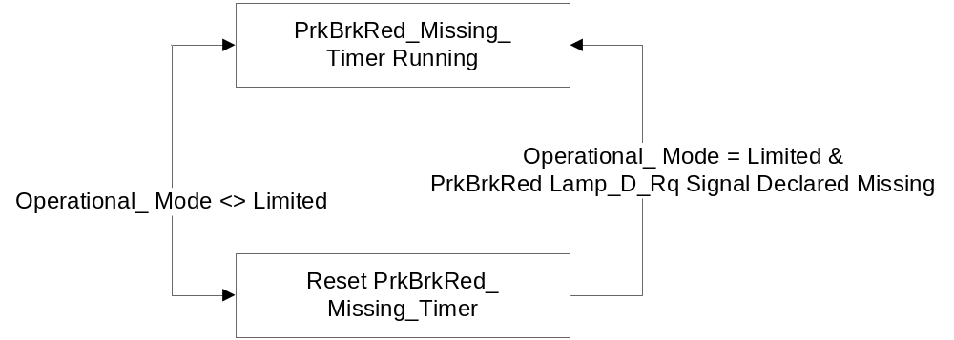

- State Matrix for Electric Park Brake Telltale
Operational_ Mode | EPB_Cfg | ETM Bulb_ Check_  State | DIAG_SESSION  _TIMER | Self_Test_ Entry_Bulb_ Check_  Timer | DIAG_DID_  61A5,4,6  (all warning lamps) | DIAG_DID_  61A4,3,2  (Electronic Park Fault) | Bulb_  Proveout_  Timer | PrkBrkYwLamp_  D_Rq Signal | EPB_ Telltale
Limited | Enabled | X | Not Active | X | X | X | X | On (0x1) | ON
Limited | Enabled | X | Not Active | X | X | X | X | Slow_Flash (0x2) | Flash @ .5Hz 50% Duty Cycle
Limited | Enabled | X | Not Active | X | X | X | X | Fast_Flash (0x3) | Flash @ 2Hz 50% Duty Cycle
Limited | Enabled | X | Not Active | X | X | X | X | Never Received | OFF
Limited | Enabled | ON (0x1) | Not Active | X | X | X | X | X | ON
Normal or Crank | Enabled | X | Not Active | X | X | X | Active | X | ON
Normal or Crank | Enabled | X | Not Active | X | X | X | X | On (0x1) | ON
Normal or Crank | Enabled | X | Not Active | X | X | X | X | Slow_Flash (0x2) | Flash @ .5Hz 50% Duty Cycle
Normal or Crank | Enabled | X | Not Active | X | X | X | X | Fast_Flash (0x3) | Flash @ 2Hz 50% Duty Cycle
Normal or Crank | Enabled | X | Not Active | X | X | X | X | Declared missing  as per SPSS | ON
Normal or Crank | Enabled | X | Not Active | X | X | X | X | Never Received | ON
Normal or Crank | Enabled | ON (0x1) | Not Active | X | X | X | X | X | ON
Normal | Enabled | X | Active | Not Active | Not Received | Not Received | Active | X | ON
Normal | Enabled | X | Active | Not Active | Not Received | Not Received | X | On (0x1) | ON
Normal | Enabled | X | Active | Not Active | Not Received | Not Received | X | Slow_Flash (0x2) | Flash @ .5Hz 50% Duty Cycle
Normal | Enabled | X | Active | Not Active | Not Received | Not Received | X | Fast_Flash (0x3) | Flash @ 2Hz 50% Duty Cycle
Normal | Enabled | X | Active | Not Active | Not Received | Not Received | X | Declared missing  as per SPSS | ON
Normal | Enabled | X | Active | Not Active | Not Received | Not Received | X | Never Received | ON
Normal | Enabled | X | Active | X | ON (0x1) | X | X | X | ON
Normal | Enabled | X | Active | X | X | ON (0x1) | X | X | ON
Normal | Enabled | X | Active | Active | X | X | X | X | ON
Normal | Enabled | ON (0x1) | Active | X | X | X | X | X | ON
All Other Cases |  |  |  |  |  |  |  |  | OFF
X= Don’t Care,
Not Received = The state when a DIAG_SESSION_TIMER is active and the DID has not been received,
Never Received = The state of no message received and missing message timer not yet expired

Operation Description (supports algorithm flowchart /state diagram)
- Non-ECE markets must use symbol B.254 shown without word Brake for EBP faults. Canada and China are non-ECE countries and must use B.254 shown without the word Brake to insure regulatory compliance.
- ECE markets must use symbol B.01 shown in yellow for EBP faults. This is hard regulatory requirement for all ECE markets.
- There are 2 options for implementing EBP symbol strategy:
  - Use EBP_ECE_Cfg to control which of the two EBP telltale symbols are shown. This strategy is mandatory for M3 level IPC for fixed telltales that are shown in the LCD. For M2, M1, M0 (or L equivalent) to use this strategy requires 2 separate fixed telltale locations dedicated to this feature. The advantage is no additional applique complexity. Internal supplier config bit may be used instead of EBP_ECE_Cfg at application engineer’s discretion but that will require unique IPC end items.
  - Use the same Fixed LED telltale space for both symbols. This strategy will require unique applique for ECE and non-ECE applications. This strategy will work for M2, M1, M0 (or L - IPC equivalent) but NOT for M3 IPC where the fixed telltale is implemented in an LCD. For this implementation the EBP_ECE_Cfg is not used.
- Speedometer bias configuration CANNOT BE USED instead of Electric Park Brake ECE configuration. China gets ECE Speedometer bias even though China is NOT an ECE market therefore a the separate configuration bit is required.

Function Safety Classification (EMC)

B

Memory Storage

Parameter Name | Description | Value at  Battery Connect | Value at  Module Wake-up
Brake_Telltale | Controls the state of the LED | OFF (0x0) | OFF (0x0)
EPB_Telltale | Controls the state of the LED | OFF (0x0) | OFF (0x0)
BrkWarnInd_B_Rq signal | CAN signal sent from the BCM | On (0x1) | On (0x1)
BrkLamp_B_Rq signal | CAN signal sent from the ABS_ESC | No (0x0) | No (0x0)
PrkBrkYwLamp_D_Rq signal | CAN signal | OFF (0x0) | OFF (0x0)
PrkBrkRedLamp_D_Rq signal | CAN signal | OFF (0x0) | OFF (0x0)
BrkPadMsgTxt_D_Rq Signal | Input CAN Signal from the VDM | Null (0x0) | Null (0x0)
ABS_Cfg | State Indicator for feature presence controlled via CAN at EOL at VO plant. Defaulted to Enabled at cluster supplier manufacturing plant. | Use Stored Value | Use Stored Value
EPB_Cfg | State Indicator for feature presence controlled via CAN at EOL at VO plant. Defaulted to Disabled at cluster supplier manufacturing plant. | Use Stored Value | Use Stored Value
EBP_ECE_Cfg | Added configuration to control display of non-ECE / ECE EBP fault telltale symbol. | Use Stored Value | Use Stored Value
CeramicBrkWear_Cfg | State Indicator for feature presence controlled via CAN at EOL at VO plant. Defaulted to DISABLED at supplier manufacturing. | Use Stored Value | Use Stored Value
DIAG_DID_61A4,3,2 (Electronic Park Fault) | Warning Lamp Status 1, byte 3, bit 2 (Park Brake) | 0 (0x0) | 0 (0x0)
DIAG_DID_61A4,3,3 (Park Brake) | Warning Lamp Status 1, byte 3, bit 3 (Park Brake) | 0 (0x0) | 0 (0x0)
DIAG_DID_61A5,4,6 (all warning lamps) | Warning Lamp Status 2, byte 4, bit 6 (all warning lamps) | 0 (0x0) | 0 (0x0)
ETM_Bulb_Check_State | State indicator for warning bulb in ETM | OFF (0x0) | OFF (0x0)
Operational_Mode | 4 state indicator for cluster operational mode | Limited | Limited or Normal or Crank

Timer Name | Description | Value at  Battery Connect | Value at  Module Wake-up
DIAG_SESSION_TIMER | Timer used to time-out a diagnostic session | Not Active | Not Active
Bulb_Proveout_Timer | Internal command directing proveout | Not Active | Not Active
Self_Test_Entry_Bulb_Check_Timer | Timer used in diagnostic session to do a self check of telltales | Not Active | Not Active
PrkBrkRed_Missing_Timer | 10 second Timer used in Limited Mode when PrkBrkRedLamp_D_Rq Signal is declared missing | Not Active | Not Active

Prove Out

3.0 +/- 0.1 seconds as per bulb prove out section. Cluster controls prove out. No DTCs shall be logged while in Prove Out.

Reconfigurable Telltale

No

Message Center Msg

No

Error Handling

Missing Message Strategy
The signals will be declared missing as per the Diagnostics section of this SPSS.

DTCs states and history will be determined as per the Diagnostics section of this SPSS.

If ABS_Cfg = Disabled, the cluster shall never log a missing message DTC due to this feature.

If EPB_Cfg = Disabled, the cluster shall never log a missing message DTC due to this feature.

If CeramicBrkWear_Cfg = Disabled, the cluster shall never log a missing message DTC due to this feature.

Diagnostics

Self Test

Bulb illuminated during self test as per Self_Test_Entry_Bulb_Check_Timer

Engineering Test Mode

Reference section “Dealer / Engineering Test Mode (ETM)”

Part II Performance

Supported Diagnostic DIDs (Service $22 and $2F)
Number | DID / CommonID Name | DID Type
61A4 | Warning Lamp Status 1, byte 3, bit 2 (Electronic Park Fault) | Bit Mapped
61A4 | Warning Lamp Status 1, byte 3, bit 3 (Park Brake) | Bit Mapped
61A5 | Warning Lamp Status 2, byte 4, bit 6 (all warning lamps) | Bit Mapped

Supported Diagnostic Trouble Codes (DTCs)

DTCs shall be logged as per the diagnostic section of this SPSS.

DTC | Description
C14000 | Lost communication with Body Control Module (BCM)
C12100 | Lost communication with Anti-Lock Brake System (ABS) Control Module
C12200 | Lost Communication with Vehicle Dynamics Module

DID DExx
Block  Num | Block Description | Byte(s) | Bits | State: Description | "0" | "1" | Default | Comments/Information
PACKETED BLOCKS
$xx | Option Content (B&A) | * | * | ABS Configuration | Disable(d) | Enable(d) | Enable(d) | Not Dealer Configurable
$xx | Option Content (B&A) | * | * | Electric Park Brake Configuration | Disable(d) | Enable(d) | Disable(d) | Not Dealer Configurable
$xx | Option Content (B&A) | * | * | Electric Park Brake ECE Configuration | Disable(d) | Enable(d) | Disable(d) | Not Dealer Configurable – Enabled for ECE regulatory countries. Must be disabled for non ECE markets including China/Canada
$xx | Option Content (B&A) | * | * | Ceramic Brake Pad Wear Indicator | Disabled | Enabled | Disabled | Feature enabled only for S550 SVT with Ceramic Brake Pads  Not Dealer Configurable.
*Byte and bit location to be identified in Part II Specification for this cluster

Reference Specification

AN-0280 BRAKE FLUID LEVEL SWITCH CONNECTION

IH-0001 TELLTALE AND INDICATOR ILLUMINATION COLOR AND INTENSITY
IH-0002 GENERAL ILLUMINATION DIMMING
IH-0003 CRAFTSMANSHIP/PERCEIVED QUALITY
IH-0004 GENERAL ILLUMINATION COLOR
IH-0005 OPERATIONAL ENVIRONMENT FUNCTIONALITY
IH-0006 TELLTALE COLOR
IH-0007 TELLTALE AND INDICATOR OPERATIONAL FUNCTIONALITY
IH-0008 ILLUMINATION ACCEPTABILITY
IH-0009 NON DIMMABLE DOOR TRIM COMPONENTS
IH-0010 CHIME SOUND QUALITY
IH-0011 SWITCH FEEL
IH-0012 SWITCH SOUND QUALITY
IH-0013 INDICATOR/JEWEL DESIGN

IS-0001 WARNINGS/INDICATORS/DISPLAYS PROVEOUT
IS-0046 INSTRUMENTATION MATERIAL RESISTANCE TO CLEANING
IS-0052 OPERATING VOLTAGES - FUNCTIONAL/PERFORMANCE
IS-0069 FUNCTIONAL IMPORTANCE CLASS
IS-0324 WINDSHIELD & OTHER REFLECTIONS
IS-0327 WARNING INDICATOR EVALUATION
IS-0329 FLICKERING OF LAMPS
IS-0379 NORTH AMERICAN WARNINGS AND INDICATORS STRATEGY

03-0661 PLACEMENT: CONTROL AND DISPLAY LOCATIONS
03-0662 PLACEMENT: LOGICAL GROUPING FUNCTION AND USAGE
03-0664 PLACEMENT: DOWN VISION TO COMPONENTS WITH HIGH VISUAL DEMAND
03-0665 PLACEMENT: EXPECTED LOCATIONS OF CONTROLS AND DISPLAYS VDS
03-0670 INTERIOR VISIBILITY
03-0671 INTERIOR VISIBILITY: REFLECTIONS FROM COMPONENTS & SURFACES
03-0672 INTERIOR VISIBILITY: REFLECTIONS IN DISPLAYS
03-0673 INTERIOR VISIBILITY: VISUAL OBSCURATIONS
03-0674 INTERIOR VISIBILITY: ILLUMINATION CONTROLS / DISPLAYS
03-0675 INTERIOR VISIBILITY: VEILING GLARE
03-0677 INTERIOR VISIBILITY: SUNLIGHT WASHOUT
03-0681 IDENTIFICATION: CHARACTER AND SYMBOL SIZE
03-0682 IDENTIFICATION: LEGIBILITY
03-0685 IDENTIFICATION: SYMBOLS, ABBREV FOR CONTROL
03-0721 LOGIC OF OPERATION: OPERATIONAL STEREOTYPES
03-0722 LOGIC OF OPERATION: INTERPRETATION
03-0723 LOGIC OF OPERATION: USE OF SYSTEMS WITH VISUAL DISPLAYS

Revision History

SPSS Module Revision History

Revision Level | Name | Change Description | Date
1.0 | V. Patel | Updated for CGEA 1.3 based on CGEA STSS v1.1  Section 1.2.2 – Deleted table referencing the HS-CAN message that contains the input signal. Deleted “ID” and “POS” columns from table 1.0 and 1.1  Table 1.1 - Changed wording from “Missing as per 1.4.1” to “Declared missing per SPSS” where applicable.  Section 1.4 – Rewritten. Deleted references of specific missing message flags and timer.  Section 1.5.3 – Deleted DTC logging criteria from table. | 3/26/2010
1.1 | V. Patel | Replaced the “Brake_Warn_Indicator_Rqst” Signal with the “BrkWarnInd_B_Rq” Signal thru out the STSS as per the change made by the BCM module.  Change applied in section 1.1, figure 1, table 1.1, table 1.2 and Memory Storage table. | 9/15/2010
2.0 | J. Gregoire | Update to support Electric Park Brake  Section 1.1 – Added Electric Park Brake description.  Figure 1 – Add EPB_Cfg, input signals PrkBrkYwLamp_D_Rq and PrkBrkRedLamp_D_Rq, and output EPB_Telltale.  Table 1.2 – Added for signal PrkBrkYwLamp_D_Rq  Table 1.3 – Added for signal PrkBrkRedLamp_D_Rq,  Section 1.2.3 - Added EPB_Telltale output  Section 1.3.1 – Added EPB Telltale  Section 1.3.3.2 – Added EPB Telltale symbol.  Section 1.3.3.2.1 – Updated IL-0017 to IH-0001. Added Yellow color.  Section 1.3.3.2.2 – Added Electric Park Brake.  Section 1.3.4 – Added Electric Park Brake.  Section 1.3.5.1 – Added Electric Park Brake configuration, Added PrkBrkRed_Missing_Timer State Diagram  Table 1.4 – Added EPC_Cfg and signal PrkBrkRedLamp_D_Rq,  Table 1.5 – Added for Electric Park Brake telltale.  Section 1.3.5.4 – Added EPB_Telltale, PrkBrkYwLamp_D_Rq signal, PrkBrkRedLamp_D_Rq signal, EPB_Cfg, and PrkBrkRed_Missing_Timer.  Section 1.4.1 – Added EPB_Cfg  Section 1.5.3 – Added EPB_Cfg  Section 1.6 – Added IH SDS. | 11/18/2010
2.1 | J. Gregoire | Table 1.4 – Updated row with PrkBrkRedLamp_D_Rq = missing with Operational Mode = Limited and rows with PrkBrkRedLamp_D_Rq = 0x2, 0x3, or missing with Operational Mode = (Normal or Crank) or Normal. | 2/11/2011
2.2 | J. Gregoire | Table 1.4 – Add two rows with ABS_Cfg = Disabled. Changed ABS_Cfg from X to Enabled for two rows above new rows. | 2/21/2011
3.0 | J. Gregoire | Figure 1 – Add DIAG_DID_61A4,3,2 (Electronic Park Fault)  Section 1.2.2 – Add DIAG_DID_61A4,3,2 (Electronic Park Fault)  Section 1.3.1 – Added EPB Telltale to Limited Mode  Table 1.5 – Added Limited Mode. Added PrkBrkYwLamp_D_Rq Signal = Not Received. Add DIAG_DID_61A4,3,2 (Electronic Park Fault)  Section 1.3.5.4 – Add DIAG_DID_61A4,3,2 (Electronic Park Fault)  Section 1.5.3 – Add DIAG_DID_61A4,3,2 (Electronic Park Fault) | 8/24/2011
3.1 | Jblatchf | Very minor change links telltale flag to graphic. Electric Park Brake Telltale graphic changed to reflect as manufactured.  - 1.3.3.2: Added flag / name of telltale to each graphic.  - Updated EPB_Telltale symbol to remove word PARK to match as manufactured. | 9/17/12
3.2 | S. Watkins  M. Hakim | Sections 1.2.1, 1.3.5.1, and 1.5.3:  Updated the configuration DID number from “DE00” to “DExx”.  Section 1.3.5.1, Table 1.5 [Denso Q/A: CD4xx_976]  Deleted Top Row of table as Bulb Prove Out cannot happen while in Limited Mode.  Section 1.3.5.4 Memory Storage:  Updated the initialization of CAN signal “BrkLamp_B_Rq” at Battery Connect and at Module Wake-up from “Yes (0x1)” to “No (0x0) ”, to be consistent with initialization of same signal in Brake Warning STSS.  Updated document footer. | 8/9/2013
4.0 | J.Blatchford | This change adds unique symbol for EBP faults for ECE markets as required by recent interpretations of ECE regulation. All changes shown in red.  - 1.1: Added bottom 2 paragraphs.  - Figure 1: Added configuration.  - 1.3.3.2: Added new EBP symbol and updated text associated with both EBP symbols.  - 1.3.5.1: Added EBP_ECE_Cfg to configuration flowchart.  - 1.3.5.2: Added notes to Operation Description.  - 1.3.5.4: Added configuration.  - 1.5.3: Add configuration to DID DExx table. | 10/21/13
1.0 | J.Blatchford | This STSS is S550 SVT specific. Created from Brake Telltale CGEA 1.3 v4.0. This STSS adds BrkPadMsgTxt_D_Rq signal as an input to the red brake telltale for this application only. This change also updates symbol B.900 to new number B.254. All changes in red.  1.1: Added signal and third paragraph.  Figure 1: Added signal and configuration.  Table 1.0: Added Table for new signal.  1.3.5.1: Added configuration.  Table 1.4: Added config and signal.  1.3.5.4: Added signal and config.  1.4.1: Added Config  1.5.3: Added DTC, added config to DID DExx  Throughout document symbol B.900 changed to symbol B.254. B.254 is the same as symbol B.900 except the word brake has been removed. B.254 may be used with the word Brake (like B.900) but for this application the word brake is not used. | 12/3/2013
1.1 | J.Blatchford | - 1.5.3: Added note that Ceramic Brake Pad DID DExx is not dealer configurable.  - Updated footer to match STSS name. | 12/3/13

